Preparation for
Foundational Motivational Interviewing Workshop

To facilitate movement through practice exercises in this workshop, please prepare the following items in advance and have them with you at our workshop. This should take approximately 15 - 20 minutes.
In our Motivational Interviewing training, we prefer to use “real-play” in which people talk about themselves, rather than “role-play” in which participants pretend to be someone they are not. We find that this accelerates learning and understanding of Motivational Interviewing for the learner. We will therefore be asking you throughout the workshop to speak about yourself during these practice exercises. Use your good judgment about topics that are comfortable and appropriate for you to discuss with a small group of skillful, empathic listeners. A purpose of this Preparation Workbook is to help you pre-select materials that may be used at specific points in this workshop.

1. Meet and Greet
What areas of your work as a helper do you currently find to be particularly challenging?

What are some of your WOW moments in the work?

In which aspects do you feel uncertain about how to progress in your efforts to enhance your helping skills?

Presence is the greatest gift you can give to another.
2. Hopes & Dreams
What are your hopes and dreams for your own life, work, relationships, etc.? Take a minute to jot down a couple or a few to have ready for real-play practice.
♥
♥
♥

3. Major Positive Personal Influences
Think about the people who have been change agents in your life. A relative, supervisor, teacher, coach, counselor, clergy, friend, etc.. List a couple of them below.
♛
♛

4. Something you should know about me
In a small group exercise, you will be asked several times to complete this sentence with a value adjective: “Something you should know about me is that I am ____________.” Each value adjective should be one that describes you well and also has some ambiguity about it.
Here are some examples of such adjectives:
Adventurous, Blessed, Cautious, Cheerful, Compassionate, Complex, Compulsive, Courteous, Curious, Diligent, Energetic, Faithful, Friendly, Generous, Persistent, Thrifty, Unconventional, Determined, Hopeful, Inquisitive, Reflective
Please list five such value adjectives that describe you well and that also have a bit of mystery about them:
Something you should know about me is that I am:
♥ ♥ ♥
♥ ♥

Stop meeting people only where they are. Meet people where they hope and dream.
5. Working definition of Motivational Interviewing (3 sentences)

6. A change I want to make
This is a change that you would like to make in yourself or your life, but haven’t done yet. Those are the two key elements: at least part of you wants to make this change, and you haven’t done it so far, and it could be long-standing. What are two potential behavior changes that you would like to make?

Empathy is a full sense of another and the ability to convey it.

7. A topic you can discuss for seven minutes
You will have an opportunity to speak with an empathic listener on some topic about yourself. It needs to be something that you can comfortably talk about for seven minutes. Some examples:
- Ways in which I have changed as a person over the years
- What I now appreciate about my childhood
- What I hope and plan to do over the next five to ten years
- How I came to do the kind of work I am doing
- An experience I had that could be difficult for someone else to understand
Please circle one of the above topics, or choose a different one and write it below:

People need to protect themselves from shame, and to dream.
8. Something I feel two ways about
Here, your topic is one about which you feel ambivalent, drawn in two different directions, and haven’t made up your mind on it yet. This is not necessarily something you want to change, or even that you need to make up your mind about. It needs to be something that is comfortable and appropriate for you to explore in a small group with empathic listeners. Please choose things that have some complexity to them. It might be, for example:
- A decision that is ahead of you
- A change that may happen
- A social, political, moral, or ethical issue in your life
- A particular person or interpersonal relationship
- How you spend your time
When you discuss these topics, the listeners will aim just to understand. Please pre-select two issues about which you feel ambivalent and have not already made up you mind that you could discuss during the workshop:

To hold the “right” position is to destroy the relationship.

9. A potential change
The issue here is a change that you have been considering making, but haven’t decided yet. So, it’s a bit different from #5, where you have already definitely decided you want and need a change. It will be something you are ambivalent about. It is a change that would be “good for you,” that you “should” or “need to” make for some reason, or perhaps have been putting off. It doesn’t have to be a problem; it could be an opportunity. What are two such changes that you have been considering?

People yearn for Power, Love, Purpose, and Belonging.

10. Resistant or discord statements that you have heard in your work settings
Make a list of at least five resistant or discord statements (sustain talk or discord) that you have heard from the people being served. If it’s not clear from the statement itself, you may need to explain the context in which it occurs in your small group.

Hold the hope until the individual can hold it themself.

11. Six month priorities in learning Motivational Interviewing
Make a list of things that are important for you to do, accomplish, complete, or make progress on during the next six months.

The individual is like a garden to be tended, not a machine to be repaired.

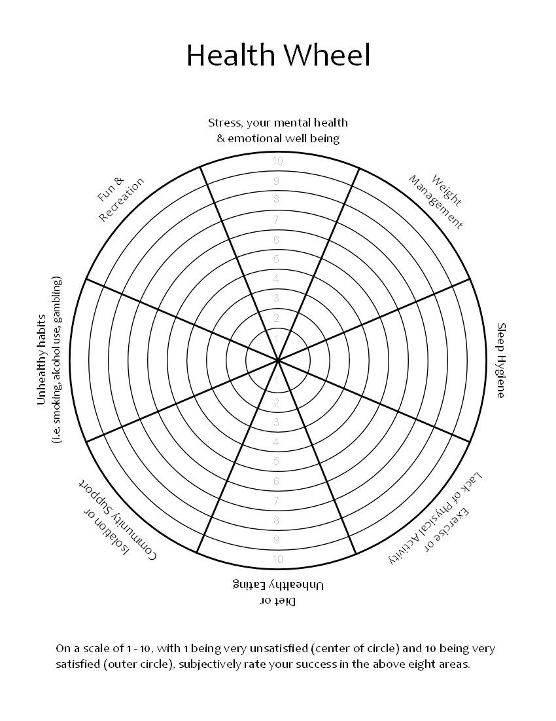

Complete this Helper’s Response Questionnaire:
What would you say next? In the workshop, you will ask a colleague to code these five statements on a scale of one to five according to their competent expression of Motivational Interviewing.
- A 20-year-old man tells you: “I know I was supposed to work on this stuff for my GED, but it just seems like a waste of time. Who will ever employ me anyway?”

- “I’ve been a client here for 5 years, and now that I’m laid off from work, and can’t pay my bill, why won’t this agency cut me some slack?”

- “I need to get back to focus on weight loss. I’ve gained all 60 pounds back since last year and lost my motivation to give up night time bingeing. It’s hard because after my divorce I’m lonely and it helps take the loneliness away.”

- “I want to quit smoking for lots of reasons – one is because I have an 11-year-old child. I stop for a while and then start again. I want to quit and I don’t want to quit. I don’t know how to figure this stuff out.”

- “I’m trying to move and exercise more but I have had exercise-induced asthma since I was a kid so I’ve learned to avoid it.”

A Taste of MI

Speaker talks about something that they want to change in their process of training.

Listener Role
(take a moment to breathe)

Listener: This exercise will take ten minutes. (one way)

- Listen carefully with the goal of understanding the speaker’s dilemma.
- Give no unsolicited advice, no self-disclosure.
Try not to ask three questions in a row.
- Ask these open questions and twice reflect the answers.
- “What are the best reasons to make this change? Why?”
- “How might you go about it, to succeed?”
- “On a scale of 1 to 10, how confident are you to make this change?”
  - Follow up question: “Why are you at ____ and not at one?”
- Offer a short summary of the speaker’s motivations to change. Do not dwell on the reasons to keep things as they are - it is fine not to mention them at all.
- Ask: “So, what do you think you’ll do?”
- Listen with interest. Listen deeply for change talk. (whispers of hopes & dreams)

Basic Coding Sheet
Overall Spirit of MI | Low 1 --- 2 --- 3 --- 4 --- 5 --- 6 --- 7 High
Response | Count | Goals
Open Questions |  | Twice as many Open as Closed
Closed Questions |  | Twice as many Open as Closed
Simple Reflections |  | Twice as many Complex as Simple
Complex Reflections |  | Twice as many Complex as Simple
Affirmations
Summaries

Overall Spirit of MI | Low 1 --- 2 --- 3 --- 4 --- 5 --- 6 --- 7 High
Response | Count | Goals
Open Questions |  | Twice as many Open as Closed
Closed Questions |  | Twice as many Open as Closed
Simple Reflections |  | Twice as many Complex as Simple
Complex Reflections |  | Twice as many Complex as Simple
Affirmations
Summaries

Thank you for your preparation for this workshop. Stephen
Adapted from the workshop packet of William Miller, PhD and Terri Moyers, PhD
October 2021, Albuquerque, New Mexico.

